**Shop On App**



**Document V.1**

**Author: Anuj Acharya**

**04/24/2012**

# Introduction

This Application will be using location-based deals targeting. This application is still in under process of development.

# Problem Statement

Buyers generally need to find deals existing near them in the local stores. This application will help the local storeowner to get more customers and the buyer can compare it with ongoing online price and get the Best Deal for the purchase

# Screen Shots

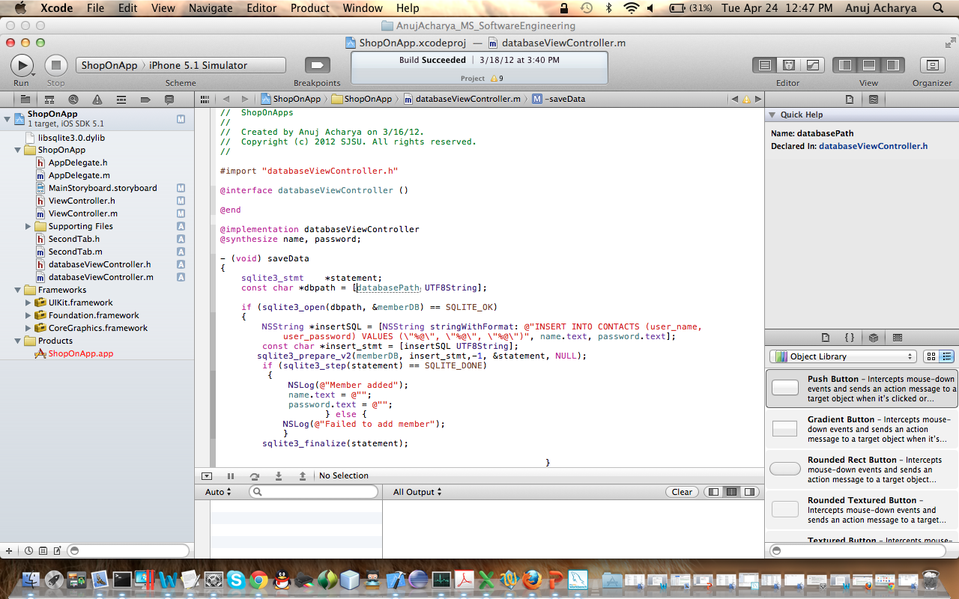

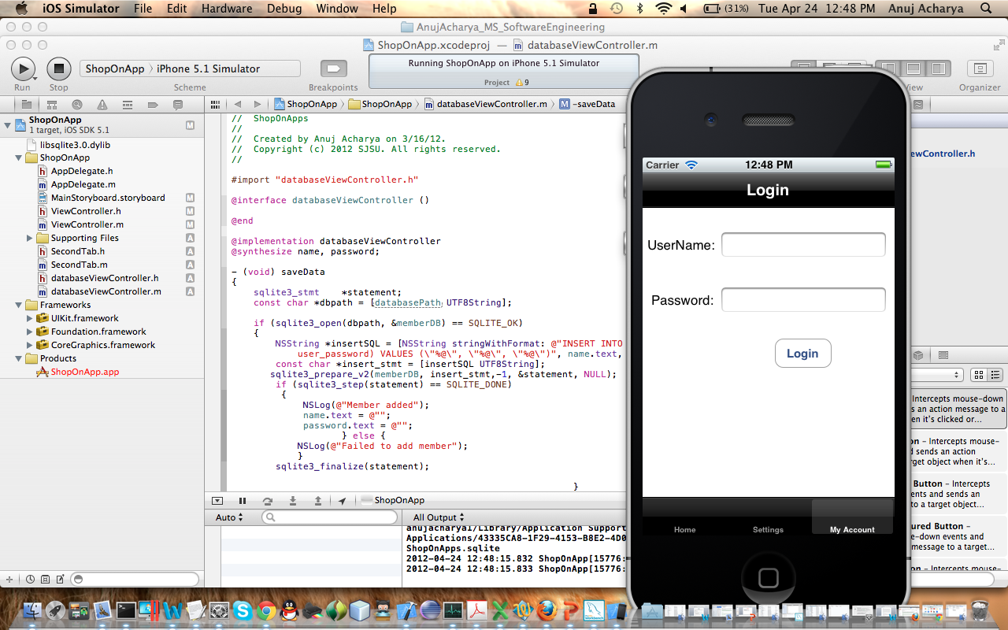

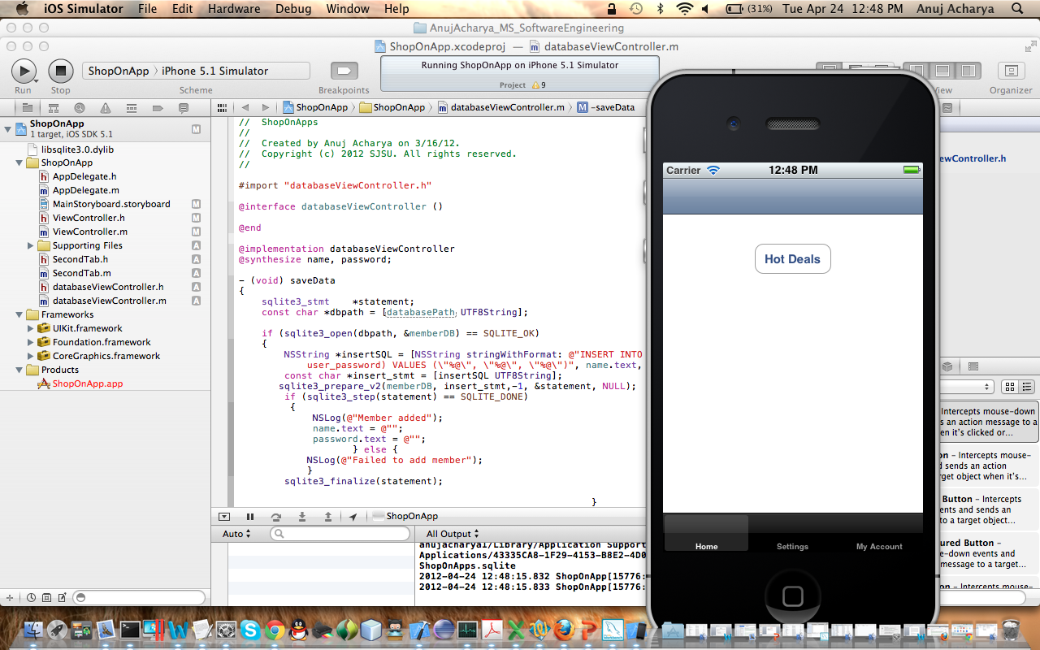

# Basic Design

On Paper

# Advantages

1. This application will help the local storeowner to get more customers
2. Buyer can compare it with ongoing online price and get the Best Deal for the purchase

# Technical Requirements

1. Using SQL Lite database for storing deals on the server
2. Using XML message to pass messages between client and server
3. Server application will be using Java with REST to send the response back to client